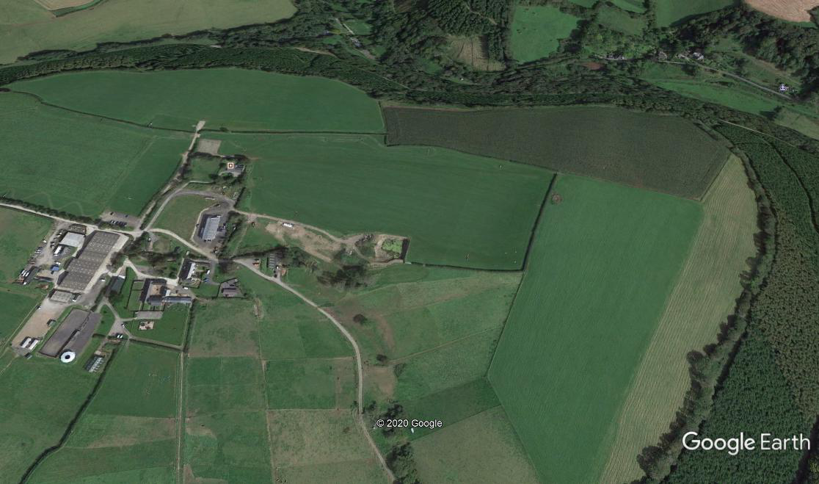

B

**T T T**

**RACE HQ**

**GLIDDON & SQUIRE NORTH DEVON CROSS COUNTRY LEAGUE**

Covid-19 SECURE AREAS

## COXLEIGH BARTON EQUESTRIAN CENTRE, SHIRWELL  EX31 4JL

**Race Distances: (all races are over a single lap to comply with Covid regs).**

**Start 1-C-D-FINISH Under 9/11 Girls & Boys: Home Field 1700 metres**

**Start 1-A-B-C-D-FINISH U13/15 Girls and Under 13 Boys: Bottom Field + Home Field = 2700 metres**

**Start 2-E-A-C-D-FINISH Under 15 Boys Under 17/20 and Senior Women: Top Field + Home Field = 3900 metres**

**Start 2-E-A-B-C-D-FINISH Under 17/20 and Senior Men: Top Field + Bottom Field + Home Field = 4900 metres**

**ALL RACES WILL BE RUN IN WAVES OF A MAXIMUM 20 ATHLETES – FINAL POSITIONS WILL BE DETERMINED BY TIMES ONLY**

**ALL RUNNERS MUST BE INSIDE THE HOLDING AREA AT LEAST 5 MINUTES BEFORE THE SCHEDULED START TIME OF THEIR RACE**

**WAVES WILL DEPART AT 90 second INTERVALS**

**THERE WILL NOT BE A NORMAL FINISH FUNNEL – RUNNERS ARE REQUIRED TO RUN THROUGH THE CLEARLY MARKED FINISH LINE AND EXIT THE SITE AS SOON AS POSSIBLE AFTER THEIR RACE. AT ALL CONFORM WITH OFFICIAL REQUESTS.**

**12/15 mm SPIKES OR FOOTBALL BOOTS ARE THE**

**RECOMMENDED FOOTWEAR**

***Terrain:***

**Top Field is dry pasture land slopes steeply down**

**to the trees at the top of the map**

**Home Field is undulating pastureland**

**Bottom Field slopes down from point A to point B**

**and is pastureland.**

**WARNING: There may be sheep droppings on the**

**course**

**S1= START 1**

**S2 = START 2**

**F = FINISH**

**T = TOILETS**

**F**

S2

**HOLDING AREA START 2**

S1

**HOLDING AREA START 1**

**Top Field to Start 1 2200m**

E

**D**

C

A

**Bottom Field 1000m**

**Home Field 1700m**