COXLEIGH BARTON EQUESTRIAN CENTRE, SHIRWELL, BARNSTAPLE EX31 4JL
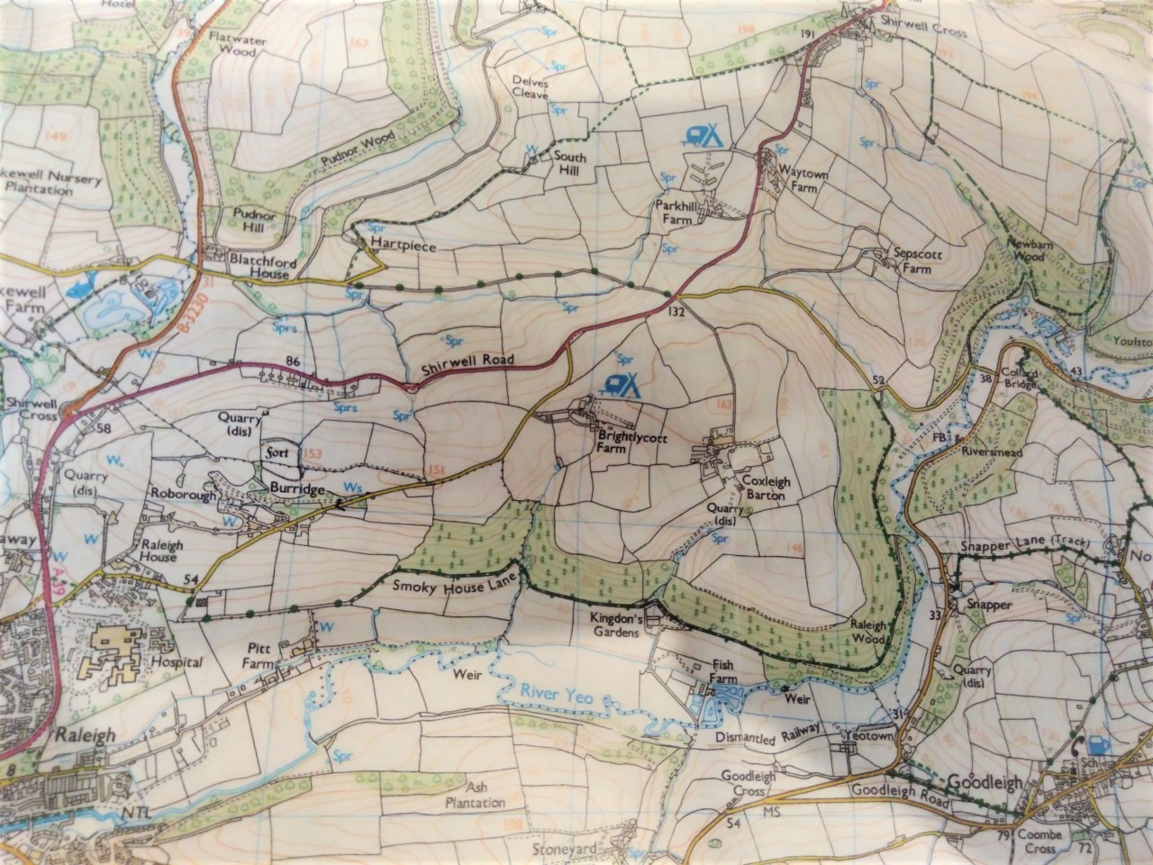
Courses
Courses

